APPLICATION - SPECIFIC ACCESS POLICIES USING ZSCALER PRIVATE ACCESS (ZPA)

TITLE : APPLICATION-SPECIFIC ACCESS POLICIES USING ZSCALER PRIVATE ACCESS (ZPA)

INTRODUCTION
In today's digital world, organizations heavily depend on computer networks and information systems to store, process, and transmit sensitive data. As technology advances, cyber threats and vulnerabilities also increase, making cybersecurity a critical requirement for protecting digital assets. Cyber attacks such as malware infections, unauthorized access, data breaches, and network intrusions can cause serious financial and reputational damage to organizations.
This project focuses on identifying and analyzing vulnerabilities in computer systems and networks using modern cybersecurity tools. Vulnerability assessment helps organizations detect weaknesses in their infrastructure before attackers can exploit them. Tools like Tenable Nessus are widely used to scan systems and identify potential security issues.
The project also explores the importance of Security Operations Center and Security Information and Event Management, which play a major role in monitoring, detecting, and responding to security incidents. Additionally, platforms such as Malware Information Sharing Platform help organizations share threat intelligence and stay updated about emerging cyber threats.
Through this project, we aim to understand vulnerability assessment techniques, analyze security risks, and propose solutions to improve the overall security posture of a network environment. The project also demonstrates how cybersecurity tools and threat intelligence can be used effectively to protect institutional networks such as those in colleges and organizations.

ABSTRACT
Cybersecurity has become an essential component in protecting digital infrastructure from increasing cyber threats and attacks. Organizations and institutions rely on secure networks and systems to maintain the confidentiality, integrity, and availability of their data. However, vulnerabilities in systems and applications can expose networks to potential security risks if they are not identified and addressed in time.
This project focuses on performing vulnerability assessment and understanding security monitoring techniques using modern cybersecurity tools and platforms. The main objective of the project is to identify vulnerabilities in systems using tools such as Tenable Nessus and analyze the security risks associated with them. The project also studies the role of security monitoring environments like Security Operations Center, which helps organizations continuously monitor and respond to cyber incidents.
In addition, the project explores Security Information and Event Management systems that collect and analyse security logs from different devices to detect suspicious activities. Threat intelligence platforms such as Malware Information Sharing Platform are also discussed to understand how organizations share information about emerging threats.
Through vulnerability scanning, analysis, and security monitoring concepts, this project demonstrates how cybersecurity practices can help protect networks from potential attacks. The findings of this project provide insights into improving the security posture of institutional networks, such as those in college environments, by implementing proper vulnerability management and threat intelligence strategies.

USE CASE SCENARIOS
Scenario 1: Detecting Web Application Vulnerabilities
Actor: Security Analyst Description:
The security analyst performs a vulnerability scan on the web application using Tenable Nessus to identify security weaknesses such as SQL Injection and Cross-Site Scripting.
Process:
- The analyst configures the scan target.
- The scanning tool analyse the application for vulnerabilities.
- The system generates a vulnerability report.
- The analyst reviews the report and identifies high-risk issues.
Outcome:
Security weaknesses in the web application are identified and documented.
Scenario 2: Preventing Unauthorized Access
Actor: System Administrator
Description:
The administrator reviews vulnerabilities related to Broken Access Control and Broken Authentication discovered during the vulnerability assessment.
Process:
- The administrator checks the vulnerability report.
- Security patches and configuration changes are applied.
- Access control policies are improved.
- The system is re-tested to verify the fixes.
Outcome:
Unauthorized users are prevented from accessing sensitive information.
Scenario 3: Monitoring Network Activity
Actor: Network Security Team
Description:
The security team monitors network traffic to detect suspicious activities using Wireshark.
Process:
- Network packets are captured and analyzed.
- Suspicious traffic patterns are identified.
- Security alerts are generated.
- The team investigates potential threats.
Outcome:
Potential cyber attacks are detected early and prevented.
Scenario 4: Network Scanning and Asset Identification
Actor: Security Engineer
Description:
The engineer performs network scanning using Nmap to identify active hosts, open ports, and services running on the network.
Process:
- The scanning tool discovers devices on the network.
- Open ports and services are identified.
Outcome:
Network assets and potential attack surfaces are identified.
Scenario 5: Strengthening Web Application Security
Actor: Web Developer
Description:
The developer reviews vulnerabilities such as Cross-Site Request Forgery and Clickjacking found during testing.
Process:
- Security vulnerabilities are analyzed.
- Secure coding practices are implemented.
- Security headers and validation techniques are added.
Outcome:
The web application becomes more secure against common attacks.
STAGE 1 TITLE : APPLICATION-SPECIFIC ACCESS POLICIES USING ZSCALER PRIVATE ACCESS (ZPA)

INTRODUCTION
Vulnerability identification is a fundamental step in the cybersecurity assessment process. As organizations increasingly rely on web applications, databases, and networked systems to manage their operations, the risk of cyber attacks has significantly increased. Attackers often exploit security weaknesses in applications, servers, or network configurations to gain unauthorized access, steal sensitive information, or disrupt services. Therefore, identifying vulnerabilities at an early stage is essential for protecting digital assets and ensuring the security of systems.
In this stage of the project, the main objective is to identify and analyse potential vulnerabilities present in the target system or web application. Vulnerabilities may occur due to insecure coding practices, improper authentication mechanisms, misconfigured servers, outdated software, or lack of proper input validation. These weaknesses can expose the system to common attacks such as SQL Injection, Cross-Site Scripting, and Cross-Site Request Forgery, which are widely exploited by attackers.
The vulnerability identification process involves scanning and testing the system to detect security flaws that could be exploited by malicious users. During this stage, different types of vulnerabilities such as authentication flaws, access control issues, information disclosure, and configuration errors are analyzed. Each vulnerability is categorized based on its severity level and its potential impact on the system. Furthermore, the vulnerability identification stage helps security professionals understand the security posture of the system and prioritize the risks that need immediate attention. By carefully examining the detected vulnerabilities, appropriate mitigation strategies and security improvements can be recommended to strengthen the overall system security.

S.NO | NAME | COLLEGE | MAIL ID
1 | RUBHA R | KPR COLLEGE OF  ARTS SCIENCE AND  RESEARCH | 23bit048@kprcas.ac.in
2 | VARSHINI S | KPR COLLEGE OF  ARTS SCIENCE AND  RESEARCH | 23bit061@kprcas.ac.in
3 | VASANTH A | KPR COLLEGE OF  ARTS SCIENCE AND  RESEARCH | 23bit062@kprcas.ac.in
4 | VETTRRIVEL | KPR COLLEGE OF  ARTS SCIENCE AND  RESEARCH | 23bit064@kprcas.ac.in

VULNERABILITY TABLE :
S. No. | VULNERABILITY NAME | CWE NO
1 | Cross Site Scripting (Stored) | CWE-79
2 | Broken Access Control | CWE-285
3 | SQL Injection | CWE- 89
4 | Broken Authentication | CWE- 285
5 | Insecure Direct Object Reference | CWE- 639
6 | Security Misconfiguration | CWE- 732
7 | Cross Site Request Forgery | CWE- 352
8 | Cleartext Transmission of Sensitive Information | CWE- 319
9 | Clickjacking | CWE- 1021
10 | Password Auto Completion Enabled | CWE- 310

- Vulnerability Name: Cross-Site Scripting (Stored)
CWE Number: CWE-79
Description : Cross-Site Scripting (XSS) is a web security vulnerability where attackers insert malicious scripts into a web application. These scripts are stored in the server and later executed in the browser of other users who visit the affected page.
Business Impact : This vulnerability can allow attackers to steal sensitive information such as user credentials, session cookies, or personal data. It can also allow attackers to perform actions on behalf of legitimate users.
Vulnerability Path: http://testfire.net/
Vulnerability Parameter: http://testfire.net/search.jsp?query='>alert('hacked')
Steps to Reproduce:
  - Open the website http://testfire.net/.
  - Navigate to the search box in the application.
  - Enter the script '>alert('hacked').
  - Submit the input.
  - A pop-up alert box appears showing “hacked”, confirming the XSS vulnerability.
Recommendation:
Validate and sanitize all user inputs.
Use output encoding to prevent script execution.
Implement secure coding practices to prevent injection attacks.

Screenshot:
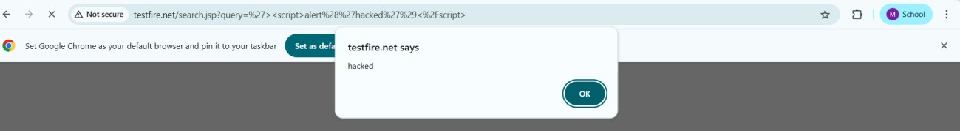

- Vulnerability Name: Broken Access Control
CWE No: CWE-285
Description: Broken Access Control occurs when a system does not properly restrict users from accessing data or functions that they are not authorized to use.
Business Impact: Attackers may gain unauthorized access to sensitive data, modify user information, or perform administrative actions.
Vulnerability Path: http://testfire.net/login.jsp Steps to Reproduce:
  - Open the website http://testfire.net/.
  - Try logging in using admin credentials.
  - Capture the request using Burp Suite.
  - The request shows username and password in clear text.
Recommendation:
Implement strong authentication and authorization mechanisms.
Use secure session management to protect user access.
Screenshot:
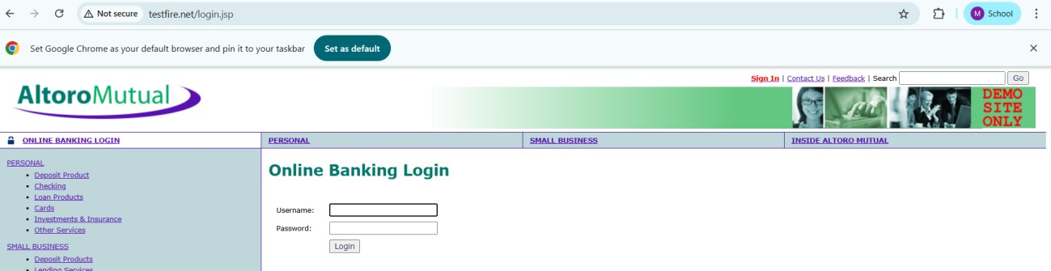
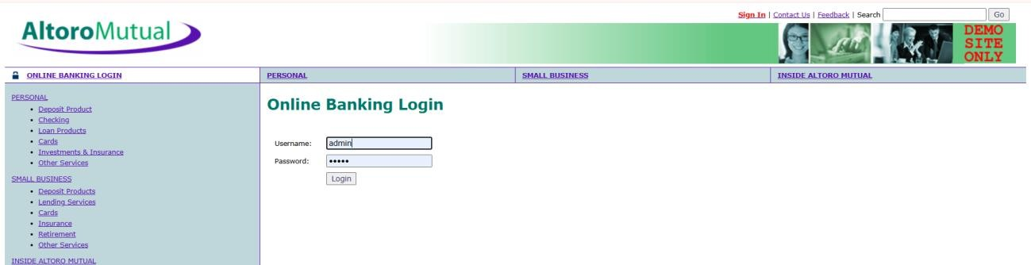
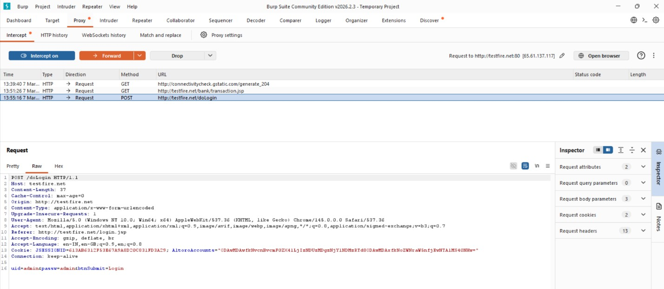
- Vulnerability Name: SQL Injection
CWE No: CWE-89
Description: SQL Injection occurs when an attacker inserts malicious SQL queries into input fields to manipulate the database.
Business Impact: Attackers can access sensitive data, modify database records, or gain unauthorized administrative access.
Vulnerability Path: http://testfire.net/login.jsp Steps to Reproduce:
  - Open the website http://testfire.net/.
  - Enter SQL injection payload in the login form.
  - Capture the request using Burp Suite.
  - The attacker may gain admin access without a valid password.
Recommendation:
Use parameterized queries or prepared statements.
Validate and sanitize all user inputs.
Screenshot:

- Vulnerability Name: Broken Authentication
CWE No: CWE-285
Description: Broken Authentication occurs when the system fails to properly manage user authentication. Attackers can bypass login mechanisms and access other user accounts. Business Impact: Attackers may gain unauthorized access to user accounts and sensitive information.
Vulnerability Path: http://testfire.net/login.jsp Steps to Reproduce:
  - Open the website http://testfire.net/.
  - Try logging in with manipulated username inputs.
  - Use SQL injection to bypass password verification.
  - Access to another user account is granted.
Recommendation:
Implement strong authentication mechanisms such as Multi-Factor Authentication (MFA).
Use secure password storage and proper session management.

Screenshot:
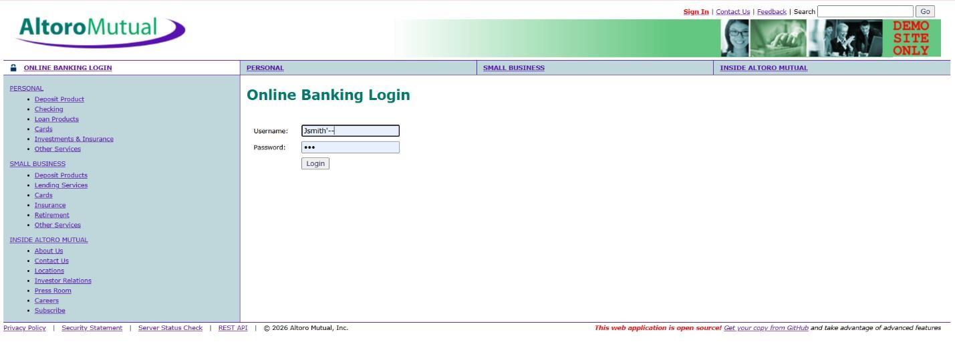
- Vulnerability Name: Insecure Direct Object Reference (IDOR)
CWE No: CWE-639
Description: IDOR occurs when a web application allows users to access or modify data by changing object identifiers such as user IDs or parameters in the URL.
Business Impact: Attackers can access or modify sensitive information of other users without proper authorization.
Vulnerability Path: http://testfire.net/bank/transfer.jsp Steps to Reproduce:
  - Open the website http://testfire.net/.
  - Login to the application.
  - Go to the “Transfer Money” section.
  - Intercept the request using Burp Suite and modify the transfer amount.
Recommendation:
Implement proper access control checks.
Validate user permissions before allowing access to sensitive data.
Screenshot:
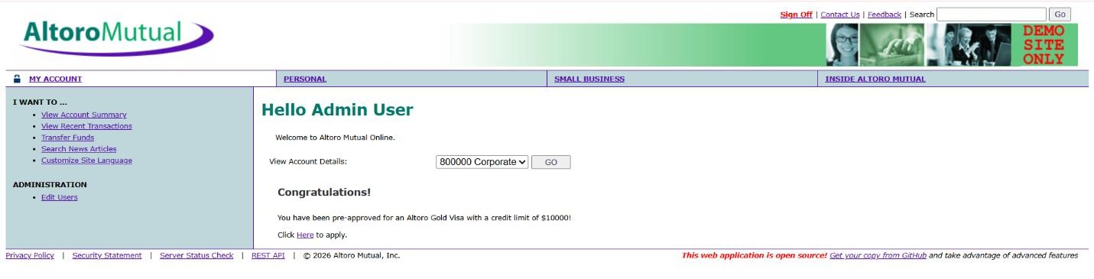
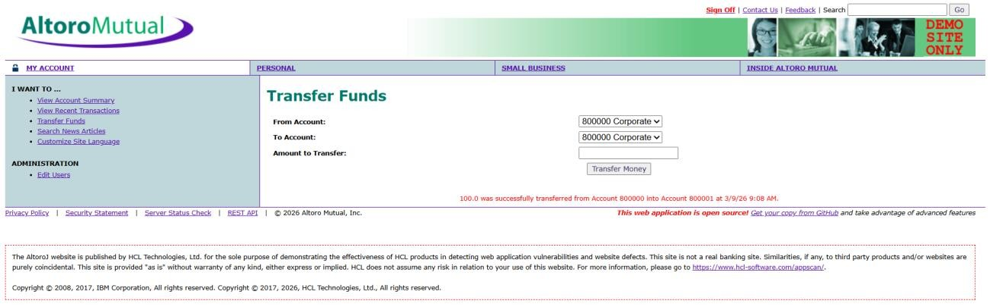

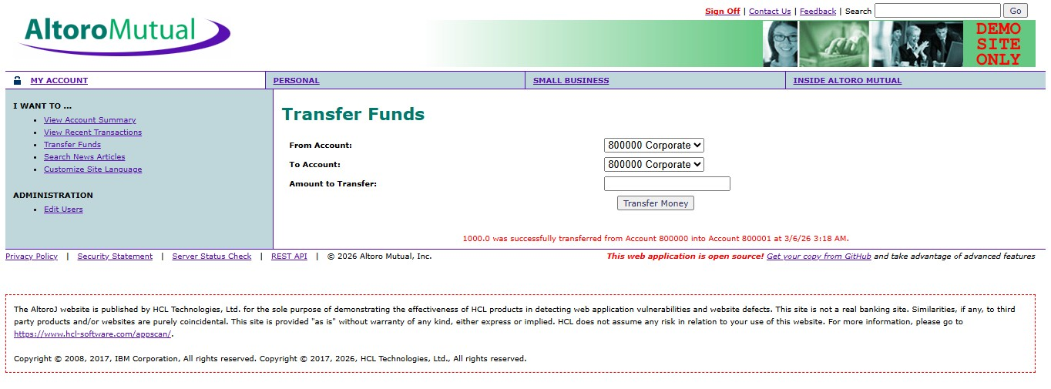
6.Vulnerability Name : Security Misconfiguration
CWE No : CWE-732
Description : Security Misconfiguration occurs when systems are not securely configured, allowing unauthorized access to sensitive files or directories.
Business Impact : Attackers may access confidential information, system files, or hidden directories due to weak security settings.
Vulnerability Path : http://testfire.net/

Steps to Reproduce :
- Open the website http://testfire.net/.
- Use scanning tools such as Uniscan in Kali Linux.
- Scan the website for hidden directories.
- The scan reveals accessible directories and sensitive files.
Recommendation :
Apply secure configuration settings for servers and applications.
Regularly perform security audits and vulnerability scans.

Screenshot :

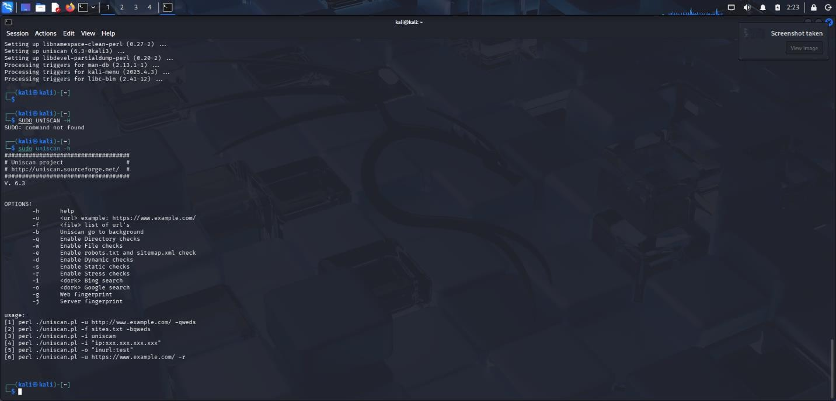

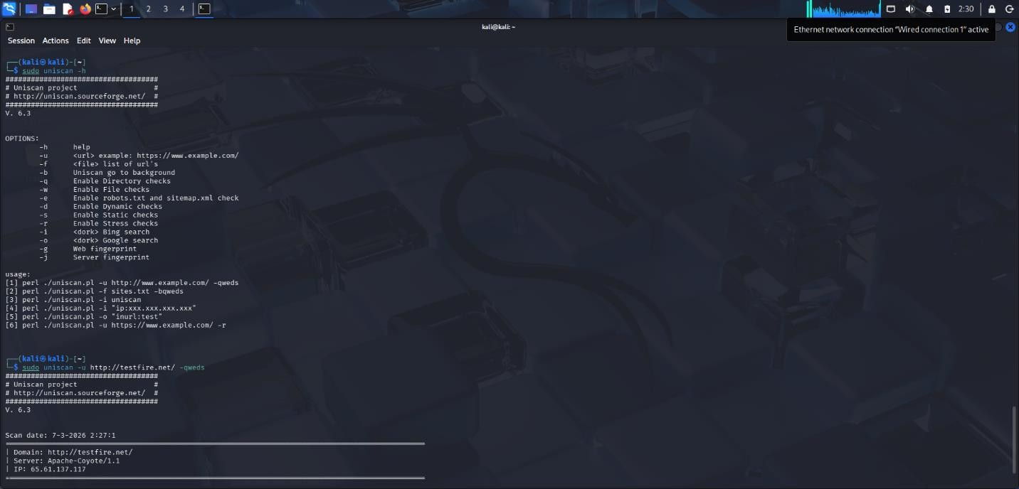

7.Vulnerability Name : Cross-Site Request Forgery (CSRF)
CWE No : CWE-352
Description : CSRF is an attack that tricks a logged-in user into performing unwanted actions on a web application without their knowledge.
Business Impact : Attackers can perform actions such as transferring funds or changing user data using the victim’s authenticated session.
Vulnerability Path : http://testfire.net/bank/transfer.jsp Steps to Reproduce :
- Open the website http://testfire.net/.
- Login using valid credentials.
- Capture the transfer request using Burp Suite.
- Generate a CSRF proof-of-concept request to perform the action.
Recommendation :
Implement CSRF tokens to validate requests.
Use secure session management techniques.
Screenshot :
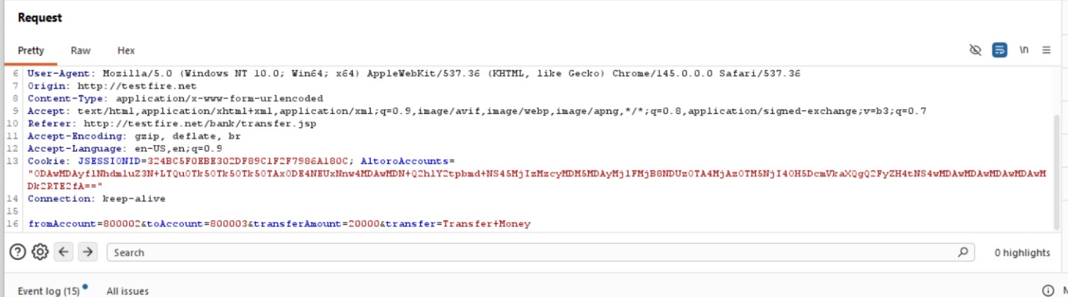

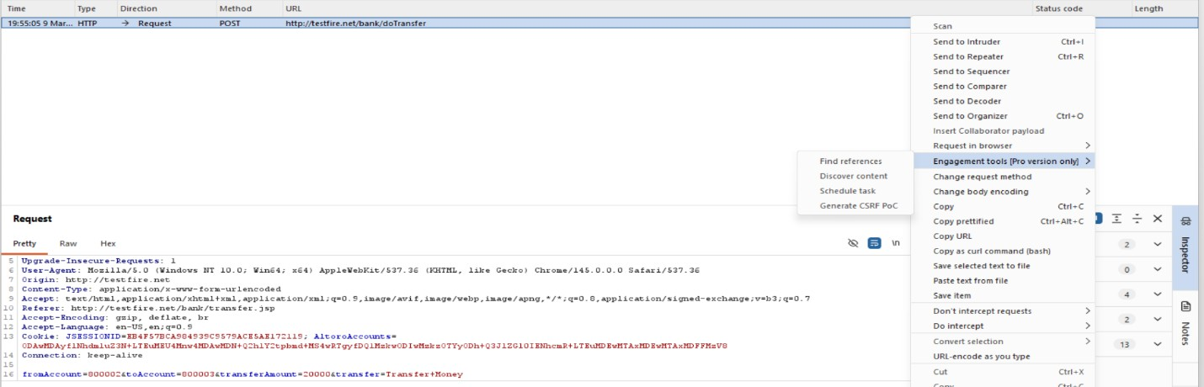
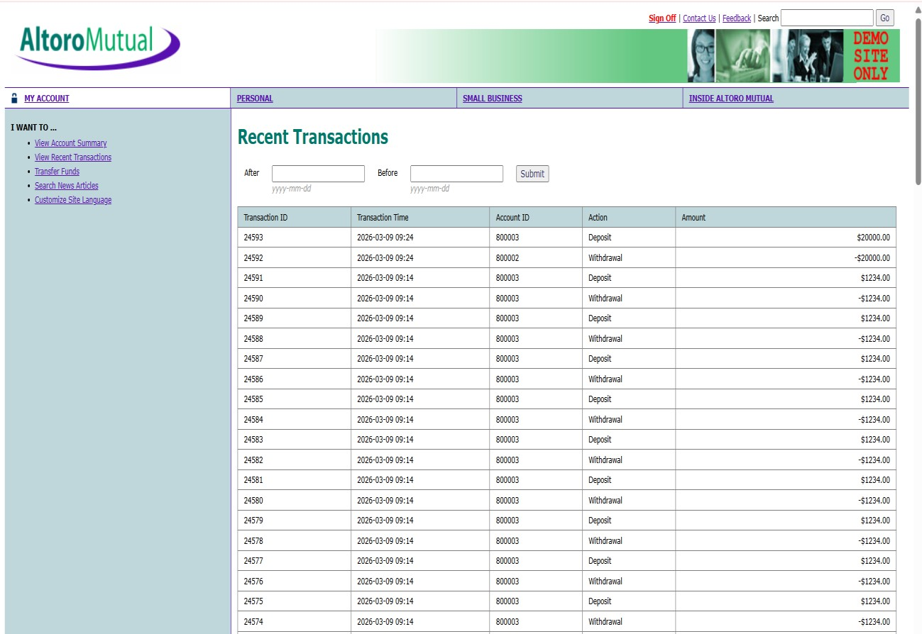

8.Vulnerability Name : Cleartext Transmission of Sensitive Information
CWE No : CWE-319
Description : This vulnerability occurs when sensitive information such as usernames and passwords is transmitted without encryption over the network.
Business Impact : Attackers can intercept network traffic and capture sensitive information, leading to data breaches and unauthorized access.

Vulnerability Path : http://testfire.net/login.jsp Steps to Reproduce :
- Open the website http://testfire.net/.
- Login using admin credentials.
- Capture the request using Burp Suite.
- The username and password appear in clear text in the request.
Recommendation :
- Use HTTPS with SSL/TLS encryption.
- Ensure sensitive data is always transmitted securely.

Screenshot :

9.Vulnerability Name : Clickjacking
CWE No : CWE-1021
Description : Clickjacking occurs when a malicious webpage tricks users into clicking hidden buttons or links by placing the target webpage inside an invisible frame.
Business Impact : Attackers can trick users into performing unwanted actions such as clicking buttons, submitting forms, or revealing sensitive information.
Vulnerability Path : http://testfire.net/ Steps to Reproduce :
  - Open the target website http://testfire.net/.
  - Create an HTML page that loads the site inside an iframe.
  - Run the HTML file in a browser.
  - The website loads inside the frame, confirming the vulnerability.
Recommendation :
Use X-Frame-Options header to prevent framing.
Implement Content Security Policy (CSP) to block unauthorized embedding.

Screenshot :
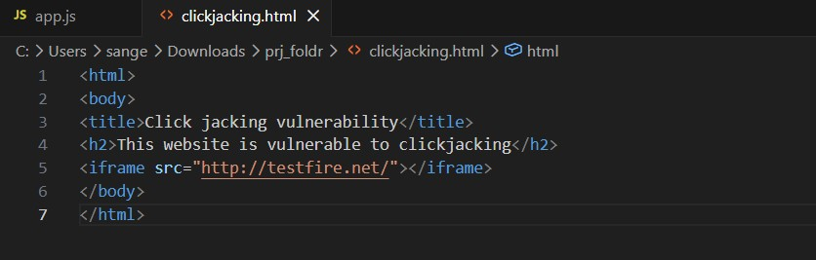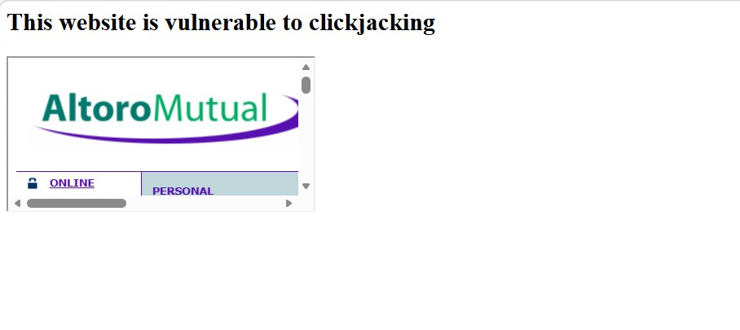
10.Vulnerability Name : Web Server Allows Password Auto-Completion
CWE No : CWE-310SSS
Description : This vulnerability occurs when the web browser automatically fills previously saved usernames and passwords on login pages.
Business Impact : Attackers who gain access to the device can easily view or use stored credentials to access the application.
Vulnerability Path : http://testfire.net/login.jsp Steps to Reproduce :
- Open the website http://testfire.net/.
- Navigate to the login page.
- Click on the username or password field.
- The browser automatically suggests stored credentials.
Recommendation :
Disable password auto-completion on login forms.
Use secure authentication mechanisms.
Screenshot :
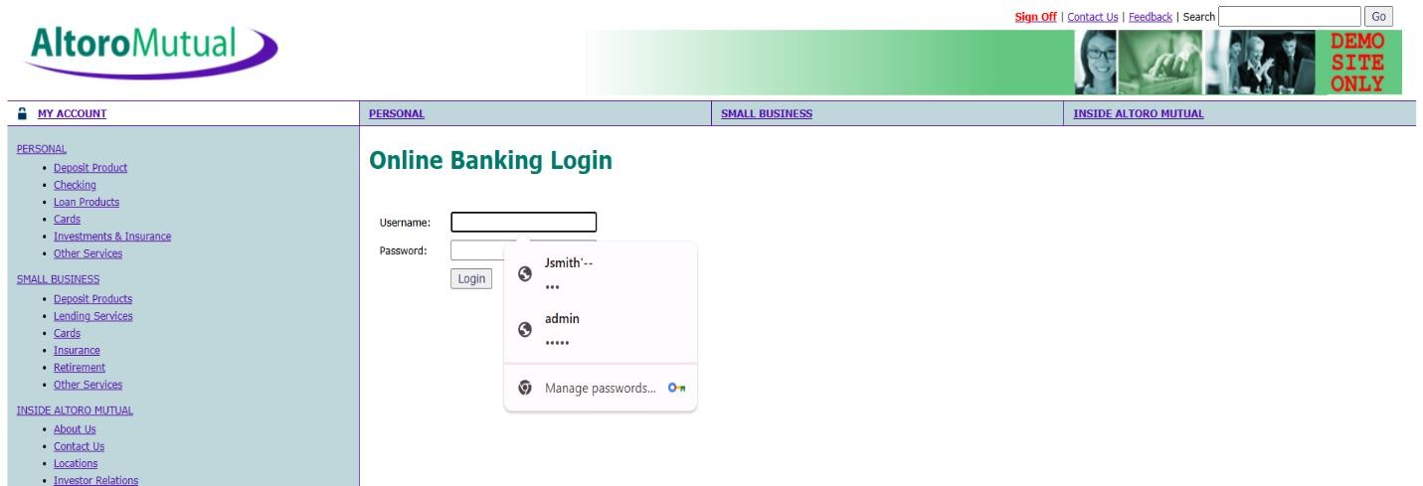

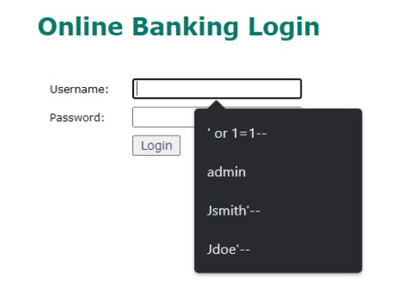

STAGE 2

OVERVIEW
Stage 2 of the project focuses on performing a detailed vulnerability assessment using automated security scanning tools. After identifying general vulnerabilities in Stage 1, this stage aims to analyze the system more thoroughly to detect specific security issues that may affect the network, servers, or web applications. Vulnerability scanning helps identify weaknesses such as outdated software, insecure configurations, open ports, and other potential security threats that could be exploited by attackers.
In this stage, a vulnerability scanning tool like Tenable Nessus is used to scan the target systems and generate detailed reports about the vulnerabilities present in the environment. The scanner checks the system against a large database of known vulnerabilities and security misconfigurations. Each identified vulnerability is categorized based on severity levels such as low, medium, high, or critical.
The results obtained from the scan help security professionals understand the potential risks in the system and prioritize them based on their impact. By analyzing these vulnerabilities, appropriate solutions and mitigation strategies can be recommended to reduce security risks and improve the overall security posture of the network.
The main objective of this stage is to document the vulnerabilities detected during the scanning process, analyze their impact, and provide remediation measures. This helps organizations maintain a secure system environment and protect sensitive information from potential cyber threats.

EXPLANATION OF TENABLE NESSUS
Tenable Nessus is a widely used vulnerability assessment tool designed to identify security weaknesses in computer systems, networks, and applications. It is developed by the company Tenable, Inc. and is commonly used by cybersecurity professionals to detect vulnerabilities before they can be exploited by attackers.
Tenable Nessus works by scanning target systems and comparing them against a large database of known vulnerabilities and security issues. The tool uses a collection of tests called plugins, which allow it to detect thousands of vulnerabilities related to operating systems, web applications, network services, and software configurations. After performing a scan, Nessus generates a detailed report that includes the vulnerability name, severity level, affected port, description of the issue, and recommended solutions.
One of the key features of Nessus is its ability to categorize vulnerabilities based on their severity levels such as Low, Medium, High, and Critical. This helps security teams prioritize which vulnerabilities should be fixed first. Nessus also provides remediation suggestions that help administrators resolve security issues effectively.

S. No | Vulnerability Name | Plugin | Port | Severity
1 | Cross Site Scripting (Stored) | 11219 | 80 | High
2 | Broken Access Control | 10759 | 80 | High
3 | SQL Injection | 10589 | 80 | Critical
4 | Broken Authentication | 10287 | 80 | High
5 | Insecure Direct Object Reference | 10815 | 80 | High
6 | Security Misconfiguration | 10674 | 80 | Medium
7 | Cross Site Request Forgery | 10916 | 80 | High
8 | Cleartext Transmission of Sensitive Information | 26194 | 80 | High
9 | Clickjacking | 11329 | 80 | Medium
10 | Password Auto Completion Enabled | 98056 | 80 | Low

REPORT :

Vulnerability Name: Cross Site Scripting (Stored)
Plugin: 11219
Port: 80
Description:
Stored Cross-Site Scripting occurs when malicious scripts are permanently stored on the server, such as in a database or comment section. When a user accesses the affected page, the script is executed in the user's browser, allowing attackers to manipulate the webpage or steal sensitive data.
Solution:
Validate and sanitize all user inputs and encode output data before displaying it on the webpage.
Business Impact:
Attackers may steal session cookies, redirect users to malicious websites, or perform actions on behalf of the user.

Vulnerability Name: Broken Access Control
Plugin: 10759
Port: 80
Description:
Broken access control occurs when the application fails to properly enforce restrictions on user access to resources. Unauthorized users may gain access to sensitive data or restricted pages.
Solution:
Implement strong access control policies and ensure proper authorization checks for all sensitive resources.
Business Impact:
Unauthorized users may access confidential information or perform administrative actions.

Vulnerability Name: SQL Injection
Plugin: 10589
Port: 80
Description:
SQL Injection occurs when attackers insert malicious SQL queries into input fields, allowing them to manipulate the backend database.
Solution:
Use parameterized queries, prepared statements, and proper input validation to prevent SQL injection.
Business Impact:
Attackers may access, modify, or delete sensitive database information.

Vulnerability Name: Broken Authentication
Plugin: 10287
Port: 80
Description:
Broken authentication occurs when authentication mechanisms are improperly implemented, allowing attackers to compromise user accounts.
Solution:
Implement strong authentication methods such as multi-factor authentication and secure password policies.
Business Impact:
Attackers may gain unauthorized access to user accounts and sensitive data.

Vulnerability Name: Insecure Direct Object Reference
Plugin: 10815
Port: 80
Description:
Insecure Direct Object Reference occurs when applications expose internal objects such as files, directories, or database records without proper authorization checks.
Solution:
Implement proper authorization checks and avoid exposing internal object references directly.
Business Impact:
Unauthorized users may access sensitive data belonging to other users.

Vulnerability Name: Security Misconfiguration
Plugin: 10674
Port: 80
Description:
Security misconfiguration occurs when systems are not properly configured, leaving unnecessary features enabled or default settings unchanged.
Solution:
Apply secure configuration guidelines, disable unnecessary services, and keep systems updated.
Business Impact:
Attackers may exploit configuration weaknesses to gain access to the system.

Vulnerability Name: Cross Site Request Forgery
Plugin: 10916
Port: 80
Description:
Cross-Site Request Forgery tricks authenticated users into performing unwanted actions on a web application.
Solution:
Use CSRF tokens and implement secure session management.
Business Impact:
Attackers may perform unauthorized actions such as changing account settings or transferring sensitive data.

Vulnerability Name: Cleartext Transmission of Sensitive Information
Plugin: 26194
Port: 80
Description:
Sensitive information such as usernames and passwords is transmitted over the network in cleartext without encryption.
Solution:
Use secure communication protocols such as HTTPS to encrypt data transmission.
Business Impact:
Attackers may intercept sensitive data using network sniffing techniques.

Vulnerability Name: Clickjacking
Plugin: 11329
Port: 80
Description:
Clickjacking occurs when attackers trick users into clicking hidden elements on a webpage using invisible frames.
Solution:
Use security headers such as X-Frame-Options or Content-Security-Policy.
Business Impact:
Users may unknowingly perform actions that compromise their accounts or data.

Vulnerability Name: Web Server Allows Password Auto-Completion
Plugin: 98056
Port: 80
Description:
The web server allows password fields to use browser auto-completion, which may store user credentials in the browser.
Solution:
Disable the auto-complete feature for password fields by using _{autocomplete="off"}.
Business Impact:
Unauthorized users who access the device may retrieve stored credentials and gain access to sensitive accounts.

STAGE 3
TITLE : APPLICATION-SPECIFIC ACCESS POLICIES USING ZSCALER PRIVATE ACCESS (ZPA)

SOC (Security Operations Center)
A Security Operations Center (SOC) is a centralized unit responsible for monitoring, detecting, analyzing, and responding to cybersecurity incidents within an organization. The SOC team continuously monitors network traffic, system logs, and security alerts to identify suspicious activities and potential threats.
The main purpose of a SOC is to protect an organization’s digital infrastructure by identifying security threats in real time and responding quickly to minimize damage. SOC teams typically consist of security analysts, engineers, and incident responders who work together to ensure the security of systems and networks.

SOC Cycle
The SOC cycle includes the following stages:
- Monitoring – Continuous monitoring of network traffic and system logs.
- Detection – Identifying suspicious activities or potential threats.
- Analysis – Investigating the detected threats to determine their impact.
- Response – Taking action to contain and eliminate the threat.
- Recovery – Restoring systems and services after the incident.
This cycle helps organizations maintain continuous security monitoring and incident response.

SIEM (Security Information and Event Management)
Security Information and Event Management (SIEM) is a security solution that collects, analyzes, and manages security data from multiple systems and devices within an organization. It helps security teams detect suspicious activities and respond to potential threats quickly.
SIEM systems gather log data from servers, applications, network devices, and security tools. By analyzing this data, SIEM tools can detect unusual patterns that may indicate cyber attacks or security breaches.

SIEM Cycle
The SIEM cycle consists of several stages:
- Log Collection – Collecting logs from various systems and devices.
- Normalization – Converting log data into a standardized format.
- Correlation – Analyzing logs to identify patterns or suspicious activities.
- Alert Generation – Generating alerts for potential security threats.
- Incident Response – Security teams investigate and respond to alerts.
This process helps organizations detect threats more effectively.

MISP (Malware Information Sharing Platform)
Malware Information Sharing Platform (MISP) is an open-source threat intelligence platform used for sharing information about cybersecurity threats. It allows organizations to share indicators of compromise (IOCs), malware information, and threat data with other organizations and security communities.
By sharing threat intelligence through MISP, organizations can stay updated about emerging cyber threats and take proactive measures to protect their systems.

College network information and the deployment details :
The college network consists of multiple interconnected systems including computer laboratories, administrative offices, and servers. These systems are connected through a local area network (LAN) and provide internet access for students, faculty members, and staff.
The network typically includes:
- Computer lab systems
- Faculty and administrative computers
- Local servers and databases
- Network switches and routers
- Internet connectivity for academic and research purposes
Since multiple users access the network, proper security monitoring and vulnerability management are essential to prevent cyber threats.
To improve cybersecurity in the college network, the following steps can be implemented:
- Perform regular vulnerability scanning using security tools.
- Monitor network activities through a centralized monitoring system.
- Collect and analyze logs from different network devices.
- Implement threat intelligence platforms to identify new threats.
- Apply security patches and updates regularly.
These steps will help detect vulnerabilities early and improve the overall security of the college network.

Threat Intelligence
Threat intelligence refers to the collection and analysis of information related to potential cyber threats. It helps organizations understand attacker behavior, identify emerging threats, and take proactive security measures.
Threat intelligence sources may include security communities, threat intelligence platforms, and cybersecurity tools. By analyzing threat intelligence data, organizations can strengthen their defense strategies and prevent cyber attacks.

CONCLUSION
The main objective of this project was to design and apply context-aware access control concepts while performing vulnerability assessment on web applications. With the rapid growth of digital technologies and online services, cybersecurity has become an essential requirement for protecting sensitive data and system resources.
Through this project, various web application vulnerabilities were identified and analyzed using security testing tools. The vulnerability scanning process helped in understanding how attackers exploit weaknesses in web applications and how these vulnerabilities can impact the security of an organization.
The analysis revealed several vulnerabilities including Cross-Site Scripting, outdated software components, information exposure issues, and configuration weaknesses. Each vulnerability highlights the importance of implementing secure coding practices, proper system configuration, and regular security testing.
This project demonstrates the role of vulnerability assessment and security testing in improving application security. By identifying and addressing security weaknesses, organizations can prevent potential cyberattacks, protect user data, and maintain system integrity.
Overall, the project emphasizes the importance of proactive security measures, continuous monitoring, and regular vulnerability scanning to ensure a secure digital environment. Implementing strong security policies and modern access control mechanisms will help organizations protect their systems against evolving cyber threats.

FUTURE SCOPE
The concepts explored in this project can be further expanded and improved with the advancement of cybersecurity technologies. As cyber threats continue to evolve, organizations must adopt more advanced tools and strategies to protect their digital infrastructure. The implementation of modern technologies such as automation, artificial intelligence, and real-time threat intelligence can significantly enhance the effectiveness of security systems.
SOC (Security Operations Center)
In the future, Security Operations Center systems can be enhanced with artificial intelligence and machine learning techniques to improve threat detection and response capabilities. AIpowered SOC platforms can automatically analyze large volumes of security data, detect abnormal patterns, and respond to incidents more efficiently. Automation can also reduce the workload of security analysts by handling repetitive tasks such as log monitoring and alert management. Advanced SOC solutions may also integrate with multiple security tools to provide a centralized security monitoring environment.
SIEM (Security Information and Event Management)
Future developments in Security Information and Event Management systems may include improved automation, faster threat detection, and better integration with cloud-based infrastructures. Advanced SIEM platforms may use machine learning algorithms to detect complex attack patterns and provide predictive threat analysis. These systems can also support real-time monitoring of large-scale networks and provide more accurate alerts to security teams, helping organizations respond to threats quickly and effectively.
MISP (Malware Information Sharing Platform)
The Malware Information Sharing Platform can be further developed to support better collaboration between organizations for sharing threat intelligence. In the future, MISP platforms may integrate with more cybersecurity tools and automated defense systems to provide real-time updates about emerging threats. Improved data sharing mechanisms can help organizations identify new attack patterns and respond to cyber threats more proactively.
Overall Future Development
In the future, cybersecurity systems may also incorporate advanced technologies such as behavioral analytics, automated incident response, and cloud security monitoring. By combining vulnerability management, threat intelligence, and continuous monitoring, organizations can create a stronger security framework. Continuous research and development in cybersecurity will help organizations adapt to evolving threats and maintain a secure digital environment.

Tools used
The project involved the use of several cybersecurity tools and technologies to perform vulnerability scanning and security analysis. These tools help security professionals identify weaknesses in web applications and understand potential attack vectors.
Kali Linux : Kali Linux is a penetration testing operating system that contains a large collection of cybersecurity tools used for ethical hacking, vulnerability analysis, and network security testing. It provides an environment for performing security assessments on systems and web applications.
Nessus Vulnerability Scanner : Nessus is a widely used vulnerability scanning tool that detects security flaws, misconfigurations, and outdated software components in servers and web applications. It provides detailed reports that include vulnerability descriptions, severity levels, and remediation recommendations.
Burp Suite : Burp Suite is a web application security testing tool used to intercept, inspect, and modify HTTP requests and responses between the browser and the web server. It helps identify vulnerabilities such as SQL Injection, Cross-Site Scripting, and authentication issues.
Web Browser : A web browser such as Google Chrome or Mozilla Firefox is used to access the target web application and perform manual security testing. Browser developer tools help inspect web page elements and analyze scripts.
Uniscan Tool : Uniscan is a web vulnerability scanning tool used to detect hidden directories, configuration issues, and potential vulnerabilities in web applications.
These tools collectively help security analysts perform effective vulnerability assessments and improve the overall security posture of web applications.

Tools explored
Burp Suite
Burp Suite is a popular web application security testing tool used by security professionals to identify vulnerabilities in web applications. It provides features such as intercepting web traffic, scanning for vulnerabilities, and testing security flaws like SQL Injection and Cross-Site Scripting.
OWASP ZAP
OWASP ZAP (Zed Attack Proxy) is an open-source web application security testing tool. It helps detect security vulnerabilities in web applications by performing automated and manual security testing. It is widely used for identifying issues such as broken authentication, cross-site scripting, and security misconfigurations.
Snort
Snort is an open-source intrusion detection and prevention system used to monitor network traffic and detect suspicious activities. It analyzes network packets in real time and generates alerts when potential security threats are detected.

